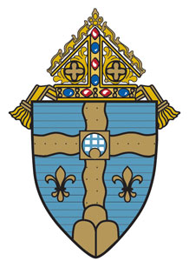

Diocese of Joliet Finance Council Meeting
November 5, 2024

TABLE OF CONTENTS

- Agenda – November 5, 2024
- September 17, 2024, Minutes
- Disposition of Prior Recommendations

- CFO Report
- Diocese of Joliet Financial Statements – Three Months Ended September 30, 2024
- Catholic Education Foundation Financial Statements – Three Months Ended September 30, 2024
- Parish Deposit and Loan Trust Financial Statements - Three Months Ended September 30, 2024
- Seminarian Endowment Trusts Financial Statements - Three Months Ended September 30, 2024
- CFO – Combined Doc
- CFO – DFC ASCA Land Sale
- CFO – 333-244-CP01-EEOPC - CDG

- Audit and Budget Committee Report
- Motion – Approval of Audited Financial Statements for June 30, 2024
- Auditors’ Report/Draft Financial Statements
  - Administration and Ministerial Services
  - Catholic Education Foundation
    - Governance Letter
  - Catholic Cemeteries
  - Deposit & Loan Trust
  - School Educational Endowment
  - Joliet Priest Pension Plan
    - Internal Control Letter
  - Joliet Retired Priests Other Benefits Plan
  - Seminarian Endowment
- Diocesan Dashboard
- Liquidity Analysis

- Development Committee Report
- Development Office Reports
- Catholic Education Foundation report

- Executive Committee Report – No Documents

- Insurance Committee Report – No Documents

- Investments and Pensions Committee Report
- Meeting Minutes – October 21, 2024
- Performance Investment Reports for the Period Ended September 30, 2024
- Summary of Performance Ended September 30, 2024

- Legal Committee Report – No Documents

- Property Committee Report
- Cemeteries Sales Report – September 2024
- Property Sales Report
- Facilities Assessment Summary

- Schools Committee Report – No Documents

- Building Commission Report – No Documents

