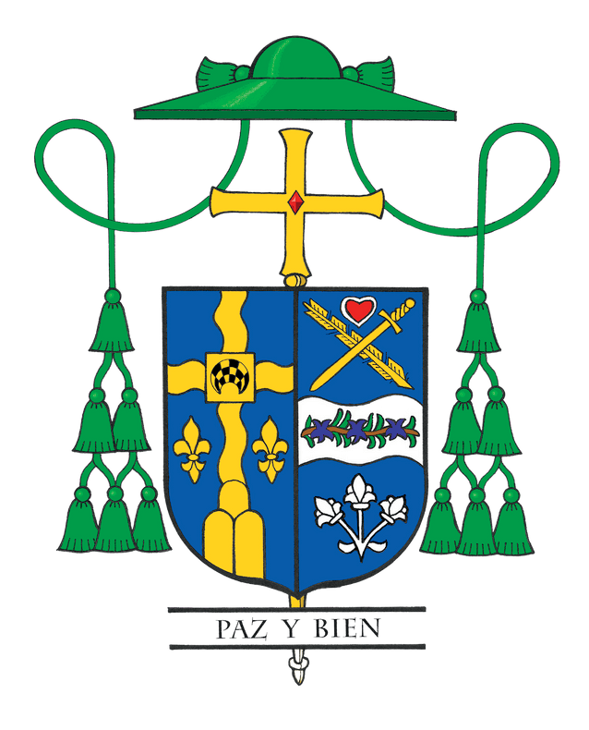
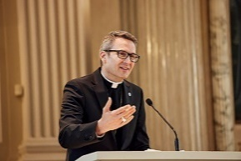
Bishop Hicks’ Column
October 2025

MAKE

When I arrived as your bishop five years ago, I laid out a vision of catechesis, evangelization, and faith into action, emphasizing that a thriving Church is one where we truly know, love, and serve God. The big question remains: how do we actually do that? How do we move from just having a vision to putting it into real practice?
This is why I wrote the pastoral letter MAKE! and launched it just this month. It builds on Bishop Conlon’s 2018 pastoral letter GO!, which draws on the Great Commission in Matthew’s Gospel (Matthew 28): “Go and make disciples.” MAKE! vulnerably reflects my heart. I love Jesus, and I want you to love Him too. It expresses my desire to give everyone a practical, loving roadmap to becoming disciples and making disciples, with a hands-on guide for passing our faith from one generation to the next.
Right before publishing it, I have to admit that I was filled with some self-doubt. I wondered, “There are so many other issues I could be writing about: the Eucharist, Pro-Life concerns, Vocations, Care of Creation, Immigration, Violence, and more. Is making disciples really the best topic?”
The Holy Spirit answered that question for me last month during a meeting at the headquarters of the United States Conference of Catholic Bishops (USCCB) in Washington, D.C. Our committee was presented with the results of a large national survey of thousands of priests across the country. One question asked, “Out of all the issues in the world, which one most needs to be addressed by our Church?” The number one response from priests nationwide was clear: passing the faith on to the next generation.
The statistician went on to explain that this does not mean priests consider the other issues unimportant. Rather, they recognize that if we do not have people in the pews, if this generation and the next are not alive in their faith and participating in the life of the Church, then all of those other issues will eventually lose their voice in the Church. We first need to form disciples who are rooted in Christ, so that they in turn can carry the mission forward and address these other urgent concerns with faith and courage.
This is why MAKE! is so important. It is not just another document, and it is certainly not meant to sit on a shelf and collect dust. It is a living invitation to every Catholic in our diocese to move from simply managing decline to boldly embracing mission. We all want to belong to a Church that is alive, thriving, and centered on the salvation of souls. That future depends on how seriously we take this call to be made into disciples so that we can go out and make disciples.
The letter offers a clear path: conversion, confession, communion, commission, all held together by prayer. These are not abstract concepts but real, concrete steps that anyone can begin today. I both invite and urge you to read the letter. And then read it again. Pray over it, discuss it with your family, your friends, or a group in your parish. Choose one small action and begin.
If each of us takes this seriously, with the guidance of the Holy Spirit, the Diocese of Joliet can become a Church on fire with love for Jesus. Boldly, I want our diocese to be the most evangelizing diocese in the country, not out of competition, but because I love Jesus, and I want you to love Him and be saved through Him too. This is our time, and this is our mission. Let us first be disciples, men and women of all ages who know, love, and serve Jesus, so that together we can go out with joy and courage to MAKE disciples, starting now.
To learn more about my pastoral letter and how to make disciples for Jesus, visit make.diojoliet.org.

