2024 WINTER DAY OF RECOLLECTION
Navigate Our Faith: THE EUCHARISTIC REVIVAL
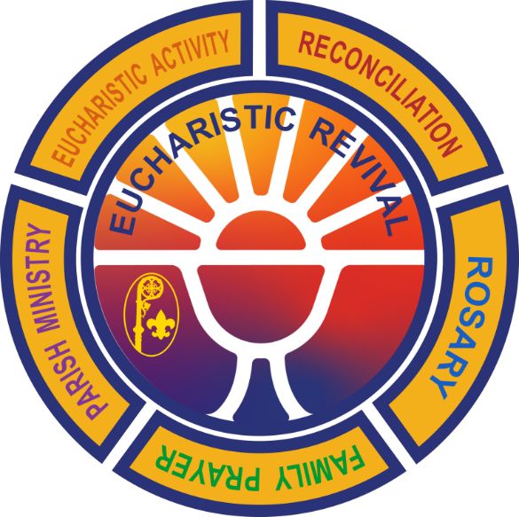
Saturday, February 17, 2024
8 am – 12 pm
St. Michael Catholic Church
310 S. Wheaton Ave. Wheaton, IL
$5 per attendee

Join us as we begin earning the LIMITED EDITION Eucharistic Revival Patch from the National Catholic Committee on Scouting. This patch is only available through 2024! Come and learn more about the Blessed Sacrament through Mass, presentations, and scouting fun with fellow Catholic Scouts from around the area. Boards of Review for Scouts BSA religious emblems will also be available.

Registration information and forms online at: https://www.jolietdiocesecatholicscouts.org/day-of-recollection
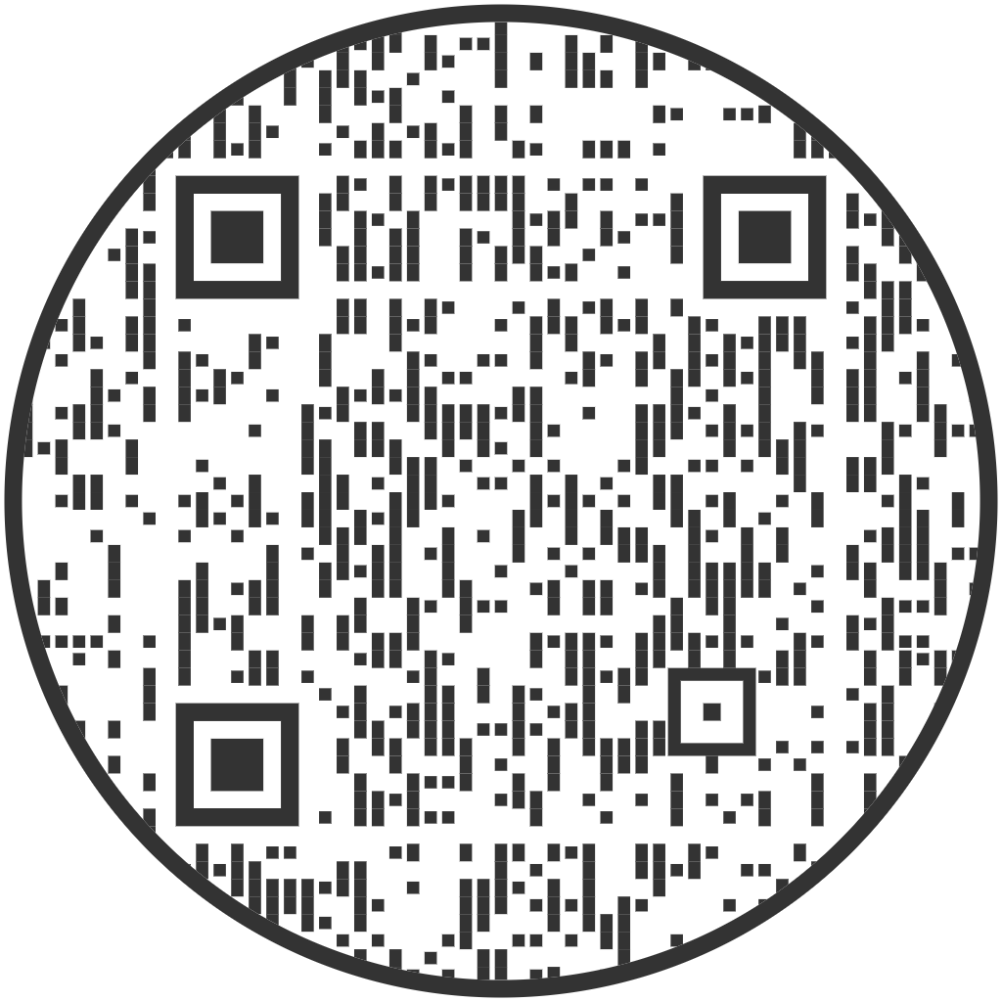

For more information, contact Karen Zeller at (630) 696-2904

