Diocese of Joliet
In partnership with Franciscan University of Steubenville School of Spiritual Direction

School of Spiritual Direction


Student Application
DEADLINE: MARCH 1, 2027
All of the following information is kept strictly CONFIDENTIAL.

DATE: / /

NAME:

ADDRESS:

CITY: STATE: ZIP:

PHONE: SECONDARY PHONE:

EMAIL: DOB: / /

CHECK ALL THAT APPLY: | 🖵 Married | 🖵 Single | 🖵 Male | 🖵 Female
 | 🖵 Permanent Deacon | 🖵 Priest | 🖵 Consecrated

EMERGENCY CONTACT: RELATIONSHIP:
Preferred phone: Secondary Phone:

IF MARRIED, FULL NAME OF SPOUSE:
Check the appropriate box:
🖵🖵 My spouse and I were married in the Catholic Church.
🖵🖵 My spouse and I had our civil marriage convalidated in the Catholic Church.
🖵🖵 My spouse and I are married civilly.
Date and city of marriage: Church of marriage (if applicable): Applicant’s number of marriages prior to current marriage: Did you receive a declaration(s) of nullity by
a diocesan tribunal for these prior marriages? Spouse’s number of marriages prior to current marriage: Even if not Catholic, did the spouse receive a declaration(s)
of nullity by a diocesan tribunal for these prior marriages?

EMPLOYMENT INFORMATION
Occupation: Work phone:
Work address:

EDUCATION AND RETREAT EXPERIENCES

Type of School | School Name &  Location | Name of Program | Duration | Degree, diploma or  certificate received
College or University
Other Education
Spirituality Workshops
Scripture or Theology Education not listed above
HEALTH

STATE ANY SPECIAL NEEDS YOU HAVE, INCLUDING DIETARY CONCERNS OR RESTRICTIONS.

DESCRIBE YOUR PSYCHOLOGICAL AND PHYSICAL HEALTH. NOTE ANY MAJOR DIFFICULTIES IN THE PAST OR PRESENT, AND INDICATE HELP YOU HAVE RECEIVED OR ARE RECEIVING FOR THEM.

DIOCESE/ECCLESIAL AFFILIATION/RELIGIOUS COMMUNITY (STATE BELOW):

PARISH/RELIGIOUS COMMUNITY (NAME & ADDRESS):

Name of Pastor/Religious Superior:

SPIRITUAL FORMATION AND RECOMMENDATIONS

My pastor/religious superior has agreed to complete the Assessment of  Applicant Form. |  Yes |  No
I am currently receiving spiritual direction. |  Yes |  No
I have contacted my spiritual director about this application (if applicable). |  Yes |  No
I have requested a Personal Reference Form from my spiritual director (if applicable). See Appendix. |  Yes |  No
I have requested permission from my religious superior to apply to the School of Spiritual Direction (if applicable). |  Yes |  No
Length of time under spiritual direction (if applicable)

SPIRITUAL DIRECTOR CONTACT INFORMATION (if applicable)
Name: Phone: Email: ADDITIONAL REFERENCE
The person named below (other than my pastor, religious superior, or spiritual director) can also
attest to my relationships with others and the Church and may be contacted on my behalf.

NAME: RELATIONSHIP: STREET: CITY: STATE: ZIP: PRIMARY PHONE: EMAIL:
HAVE YOU COMPLETED THE SPIRITUAL EXERCISES OF ST. IGNATIUS (30-DAY, 19TH ANNOTATION, 30 WKS, OR THE 8-DAY RETREAT FORMAT? BELOW, STATE WHEN & WHERE, AND DESCRIBE YOUR SPIRITUAL EXPERIENCE.

SAFE ENVIRONMENT REQUIREMENTS
BEFORE FINAL ACCEPTANCE INTO THE SSD, STUDENTS ARE REQUIRED TO COMPLETE CERTAIN COMPLIANCE STEPS IN THE VIRTUS SYSTEM. BELOW, CHECK THE BOX NEXT TO THE STATEMENT THAT DESCRIBES YOUR STATUS IN VIRTUS. (YOU MAY CHECK YOUR ACCOUNT STATUS AT virtusonline.org, OR YOU MAY CALL THE OFFICE OF CHILD AND YOUTH PROTECTION FOR ASSISTANCE AT 815-221-6118.

 | I have an active VIRTUS account.
 | My VIRTUS account is currently inactive.
 | I do not know the status of my VIRTUS account.
 | I do not have a VIRTUS account

DEPENDING ON YOUR VIRTUS STATUS, WHICH YOU HAVE INDICATED ABOVE, YOU WILL NEED TO FOLLOW THE STEPS OUTLINE BELOW:

1. | For applicants with an active VIRTUS account, download these instructions or find them in the  application appendix.
2. | For applicants whose VIRTUS accounts are currently  inactive, download these instructions or find them in the application appendix.
3. | For applicants without a VIRTUS account, download these instructions or find them in the application  appendix.
4. | For all applicants, download the required fingerprint  background check form or find a copy in the application appendix.

INTELLECTUAL FORMATION

PRIOR TO YOUR ACCEPTANCE INTO THE SSD, YOU WILL ALSO BE REQUIRED TO CREATE A LEARNER ACCOUNT IN THE CATECHETICAL INSTITUTE’S FRANCISCAN AT HOME LEARNING SYSTEM. TO SET UP
YOUR ACCOUNT, GO TO https://franciscanathome.com/diocese-joliet.

SPIRITUAL AUTOBIOGRAPHY

ANSWER THE FOLLOWING QUESTIONS ON A SEPARATE DOCUMENT. PLEASE DO NOT EXCEED MORE THAN 5 PARAGRAPHS FOR EACH QUESTION.
- What are the major duties/commitments in your life right now? How are these going?
- Who is God to you? How do you become aware of His presence? Briefly describe your prayer.
- Describe your experience of receiving spiritual direction and your understanding of spiritual direction.
- Explain at length why you feel called to the ministry of spiritual direction, and what has led you to this sense of call. What communal support are you receiving to undertake this training?
- What signs and personal gifts do you recognize as evidence of your call to this ministry? Have others confirmed these gifts?
- What areas are you most in need of growth to serve in this ministry?
- Briefly describe your spiritual journey from childhood to the present.

ACKNOWLEDGMENT
I CERTIFY THAT THE ANSWERS GIVEN BY ME IN THIS APPLICATION ARE CORRECT TO THE BEST OF MY KNOWLEDGE. I UNDERSTAND THAT MY FALSIFICATION OF THIS APPLICATION, WHETHER WILLINGLY OR ACCIDENTAL, IS GROUNDS FOR DISMISSAL FROM THE PROGRAM. IF I AM ACCEPTED, MY SPIRITUAL DIRECTOR* AND I HAVE DISCUSSED MY READINESS FOR THIS PROGRAM, AND WE HAVE TOGETHER DISCERNED A CALL TO SERVE OTHERS AS A SPIRITUAL DIRECTOR. I UNDERSTAND THAT ONGOING PARTICIPATION IS SUBJECT TO ANNUAL REVIEW.

APPLICANT’S SIGNATURE** DATE

*If the applicant does not have a spiritual director at this time, the applicant agrees to discern readiness for this program with a pastor, religious superior, or spiritual advisor for the School of Spiritual Direction.
**The parties agree that this document may be electronically signed and that the electronic signatures appearing on this document are the same as handwritten signatures for the purposes of validity, enforceability and admissibility.

FINAL CHECKLIST AND APPLICATION SUBMISSION

ALL COMPONENTS MUST BE SUBMITTED/COMPLETED BY MARCH 1, 2027 AND WILL INCLUDE:

 | This completed SSD Application form and spiritual autobiography.
 | A completed Pastor’s Assessment of Applicant Form (or, if applicable, an Assessment Form completed by another Ministerial Leader or Religious Superior (see Appendix).
 | 2 completed Personal Reference Forms, including 1 from your spiritual director if you have one (see Appendix), mailed/emailed to address below.
 | Baptismal certificate (not a photocopy) issued within the past 6 months by the church where you were baptized, showing sacraments received and imprinted with the parish seal. The certificate must be mailed to the address shown below.
 | VIRTUS account created and compliance steps completed including fingerprint background check (see Appendix).
 | Catechetical Institute Franciscan at Home account created (see Appendix).

AN OFFICIAL COPY OF YOUR BAPTISMAL CERTIFICATE MUST BE MAILED TO THE ADDRESS BELOW. ALL OTHER DOCUMENTS, INCLUDING THE COMPLETED APPLICATION, SPIRITUAL AUTOBIOGRAPHY AND REFERENCE FORMS IN SUPPORT OF THIS APPLICATION MAY BE SUBMITTED EITHER BY

U.S. MAIL TO:
Blanchette Catholic Center Office of Catechetical Formation 16555 Weber Rd.
Crest Hill, IL 60403

OR EMAIL (WITH ATTACHMENTS, EXCEPT THE BIRTH CERTIFICATE) TO:

SSD@dioceseofjoliet.org

For questions and assistance, please call 815-221-6147.

Diocese of Joliet
In partnership with Franciscan University of Steubenville School of Spiritual Direction

School of Spiritual Direction



Appendix
Additional Requirements

CONTENTS

Pastor/Religious Superior Reference Form Second Reference Form
VIRTUS Compliance (Letters 1-3)
VIRTUS Online Registration
VIRTUS Account Registration Instructions (pp. 1-5) Required Accurate Biometrics Fingerprint Background Check Form
Catechetical Institute Franciscan at Home Account Setup Instructions

—Page Intentionally Left Blank—

Diocese of Joliet
In partnership with Franciscan University of Steubenville School of Spiritual Direction
School of Spiritual Direction

Pastor/Religious Superior Assessment of Applicant

Applicant’s name
How long have you known the applicant?
How well do you know the applicant? (CHECK ONE)  Very Well  Somewhat  Hardly at all
How long has the applicant been a member of your parish or religious order?
Share your perceptions of the applicant’s faith life, participation in the sacraments, and prayer life.

Share your perceptions of (1) the applicant’s understanding of who God is and (2) the applicant’s views of Church teaching.

Please describe the applicant’s level of involvement in the parish or religious community. Specify the activities and length of involvement.

How would you rate the applicant on the following traits? (Circle 1 answer for each category).

Honesty/Integrity | Above Average | Average | Below Average | Don’t Know
Reliability | Above Average | Average | Below Average | Don’t Know
Ability to Listen | Above Average | Average | Below Average | Don’t Know
Human Relations Skills | Above Average | Average | Below Average | Don’t Know
Intelligence | Above Average | Average | Below Average | Don’t Know
Speaking Skills | Above Average | Average | Below Average | Don’t Know
Moral Values | Above Average | Average | Below Average | Don’t Know
Faithfulness to Practicing  the Catholic Faith | Above Average | Average | Below Average | Don’t Know
Confidentiality | Above Average | Average | Below Average | Don’t Know
Ability to Handle Life  Situations | Above Average | Average | Below Average | Don’t Know

Please describe the applicant’s psychological stability .

Why do you think the applicant desires to become a spiritual director?

Please comment on the applicant’s ability to listen to another’s story and ask questions.

To the best of your knowledge, does the applicant have any history of alcohol/drug abuse, spouse or child abuse, allegations of sexual misconduct involving minors, accusations of crime, indictments, arrests, convictions, or mental illness? (Check one)  Yes  No If yes, please describe.

What additional comments would you like to make about this candidate?

Considering all you know about the applicant’s personal character, family life, and motivation for becoming a spiritual director, what is your overall evaluation of the candidate?

 | The applicant is a top-notch candidate.
 | The applicant is a very good candidate.
 | The applicant is an acceptable candidate.
 | I have reservations about the applicant being a spiritual director. (On the lines below, explain why you have reservations.
 | I would not recommend the applicant. Explain your reason(s) on the lines below).

Submitted on behalf of

Applicant’s Name

Your Name

Street Address

City, State, Zip

Phone

Your Signature Date

SUBMIT THIS REFERENCE FORM NO LATER THAN MARCH 1, 2027 BY

U.S. MAIL TO:
Blanchette Catholic Center
Office of Catechetical Formation/SSD 16555 Weber Rd.
Crest Hill, IL 60403

OR EMAIL WITH A SCANNED COPY TO:

SSD@dioceseofjoliet.org

For questions and assistance, please call 815-221-6147.

Diocese of Joliet
In partnership with Franciscan University of Steubenville School of Spiritual Direction
School of Spiritual Direction

Personal Reference

Applicant Name
The above-named individual has made an application for admission to the Diocese of Joliet School of Spiritual Direction and requests that you complete this reference form.
In order for us to consider this applicant, it is necessary for us to receive this completed form. Your honest and candid evaluation will be appreciated. Your comments will be held in strict confidence by the Admissions Team and will not be shared with the applicant.
Please complete this form and return it no later than March 1, 2027 by U.S. Mail to Diocese of Joliet- School of Spiritual Direction, Blanchette Catholic Center, 16555 Weber Rd., Crest Hill, IL 60403. You may also scan it and email it to SSD@dioceseofjoliet.org. Thank you.

(Please type or print legibly)
How long have you known the applicant?

How well and in what context do you know the applicant?

What is/was your relationship to the applicant (friend, relative, employer, colleague, neighbor, etc.?

How well do you know the spiritual journey of this applicant, and what can you say about it?

Do you have any concerns about the applicant’s ability to fulfill the responsibilities of a spiritual director without harming their marital and/or family life?

Is there anything about the applicant’s history that concerns you regarding their ability to function as a representative of the Catholic Church?

What is your understanding of the applicant’s prayer and sacramental life?

Do you know of any history of emotional disorders, substance abuse, abusive relationships, criminal arrests, indictments, or convictions that might impede or hinder the applicant’s ability to serve as a representative of the Catholic Church?

What special talents, capabilities and/or strengths does the applicant possess, which would be of value to the Church?

What limitations or weaknesses, if any, does the applicant have that might hinder the ability to perform in service to the Church?

How would you rate the applicant on the following traits? (Circle 1 answer for each category).

Honesty/Integrity | Above Average | Average | Below Average | Don’t Know
Reliability | Above Average | Average | Below Average | Don’t Know
Ability to Listen | Above Average | Average | Below Average | Don’t Know
Human Relations Skills | Above Average | Average | Below Average | Don’t Know
Intelligence | Above Average | Average | Below Average | Don’t Know
Speaking Skills | Above Average | Average | Below Average | Don’t Know
Moral Values | Above Average | Average | Below Average | Don’t Know
Faithfulness to Practicing  the Catholic Faith | Above Average | Average | Below Average | Don’t Know
Confidentiality | Above Average | Average | Below Average | Don’t Know
Ability to Handle Life  Situations | Above Average | Average | Below Average | Don’t Know

Considering all you know about the applicant’s personal character, family life, and motivation for becoming a spiritual director, what is your overall evaluation of the candidate?

 | The applicant is a top-notch candidate.
 | The applicant is a very good candidate.
 | The applicant is an acceptable candidate.
 | I have reservations about the applicant being a spiritual director. (On the lines below, explain why you have reservations.
 | I would not recommend the applicant. Explain your reason(s) on the lines below).

Submitted on behalf of

Applicant’s Name

Your Name

Street Address

City, State, Zip

Phone

Your Signature Date

SUBMIT THIS REFERENCE FORM NO LATER THAN MARCH 1, 2027 BY

U.S. MAIL TO:
Blanchette Catholic Center
Office of Catechetical Formation/SSD 16555 Weber Rd.
Crest Hill, IL 60403

OR EMAIL WITH A SCANNED COPY TO:

SSD@dioceseofjoliet.org

For questions and assistance, please call 815-221-6147.

August 1, 2025
Dear Diocese of Joliet SSD Applicant,
In collaboration with the Department of Catechesis and Evangelization, our diocesan Office of Child and Youth Protection (OCYP), which oversees all safe environment guidelines for the Diocese of Joliet, has issued compliance requirements for the School of Spiritual Direction students. The enclosed information will guide you in the compliance process. The first step towards compliance is to register for a VIRTUS account, or if you already have one, to make sure it is active. If records show that you have an active account, then follow the steps outlined below.
In addition to keeping your Virtus account active, you will need to add the following “Primary” and “Secondary” Roles to your VIRTUS account, which will reflect your Role as a School of Spiritual Direction Student:
- Primary Role = “Non-employee/non-volunteer contractor”
  - Location = Blanchette Catholic Center
- Secondary Role = “School of spiritual direction student”
  - Location = Blanchette Catholic Center
The safe environment compliance requirements that all SSD students must complete are:
- Active VIRTUS account
- Acknowledgement of receipt of current diocesan policy and standards of behavior (done electronically through VIRTUS account)
- Protecting God’s Children (PGC)
- Sexual Harassment Prevention Training (SHPT) – annually per HR schedule
- Fingerprint criminal background check (name based criminal background check every 5 years thereafter). If you have never been fingerprinted for the Diocese of Joliet, please print the attached “Diocese of Joliet Fingerprint Applicant Form” or contact our office and we will provide you with a fingerprint applicant form. The diocese does not accept fingerprint results from any other agency. The fingerprint vendor used by the Diocese of Joliet is Accurate Biometrics. Please complete the applicant form and bring it with you to Accurate Biometrics, along with a valid government issued ID (such as a driver’s license, state ID, or passport). For Accurate Biometrics locations and hours of operation, please click on this link: https://accuratebiometrics.com/results-by-zip.
With an active VIRTUS account, you have already completed some of these safe environment compliance requirements. In order to determine if you are compliant or if you have any missing compliance requirements, please log onto your VIRTUS account and click on your Home tab. Green boxes indicate compliance you have completed, and red boxes indicate compliance you have not yet completed. Please click on the links within the red boxes to assist you in completing the respective compliance requirements.
The deadline to complete all these steps is March 1, 2027. If you have questions about the process, do not hesitate to contact me, Deacon Anthony Clishem, at aclishem@dioceseofjoliet.org or the Office of Child and Youth Protection at SafeEnvironment@dioceseofjoliet.org.

Sincerely in Christ,

Anthony J. Clishem
Deacon Anthony J. Clishem, Ed.D Catechetical Formation Lead Direct 815-221-6142
aclishem@dioceseofjoliet.org
encl: DOJ Catechetical Formation Fingerprint Form

—Page Intentionally Left Blank—

August 1, 2025
Dear Diocese of Joliet SSD Applicant,
In collaboration with the Department of Catechesis and Evangelization, our diocesan Office of Child and Youth Protection (OCYP), which oversees all safe environment guidelines for the Diocese of Joliet, has issued compliance requirements for the School of Spiritual Direction students. The enclosed information will guide you in the compliance process. The first step towards compliance is to register for a VIRTUS account, or if you already have one, to make sure it is active. If records show that your VIRTUS account is inactive, then follow the steps outline below.
In order to reactivate your VIRTUS account, you will need to contact OCYP at SafeEnvironment@dioceseofjoliet.org. In your email to OCYP, please indicate that you are a SSD student.
Once your VIRTUS account is active, you will also need to make sure that the following “Primary” and “Secondary” Roles are selected to reflect your Role as a School of Spiritual Direction Student:
- Primary Role = “Non-employee/non-volunteer contractor”
- Location = Blanchette Catholic Center
- Secondary Role = “School of spiritual direction student”
- Location = Blanchette Catholic Center
The safe environment compliance requirements that all SSD students must complete are:
- Active VIRTUS account
- Acknowledgement of receipt of current diocesan policy and standards of behavior (done electronically through VIRTUS account)
- Protecting God’s Children (PGC)
- Sexual Harassment Prevention Training (SHPT) – annually per HR schedule
- Fingerprint criminal background check (name based criminal background check every 5 years thereafter). If you have never been fingerprinted for the Diocese of Joliet, please print the attached “Diocese of Joliet Fingerprint Applicant Form” or please contact our office and we will provide you with a fingerprint applicant form. The diocese does not accept fingerprint results from any other agency. The fingerprint vendor used by the Diocese of Joliet is Accurate Biometrics. Please complete the applicant form and bring it with you to Accurate Biometrics, along with a valid government issued ID (such as a driver’s license, state ID, or passport). For Accurate Biometrics locations and hours of operation, please click on this link: https://accuratebiometrics.com/results-by-zip.
Because you had an inactive VIRTUS account, you may have already completed some of these safe environment compliance requirements. In order to determine if you are compliant, or if you have ay missing compliance requirements, please log onto your VIRTUS account and click on your Home tab. Green boxes indicate compliance you have completed, and red boxes indicate compliance you have not yet completed.
Please click on the links within the red boxes to assist you in completing the respective compliance requirements.
The deadline to complete all these steps is March 1, 2027. If you have questions about the process, do not hesitate to contact me, Deacon Anthony Clishem, at aclishem@dioceseofjoliet.org or the Office of Child and Youth Protection at SafeEnvironment@dioceseofjoliet.org.
Sincerely in Christ,

Anthony J. Clishem
Deacon Anthony J. Clishem, Ed.D Catechetical Formation Lead Direct 815-221-6142
aclishem@dioceseofjoliet.org
encl: DOJ Catechetical Formation Fingerprint Form

—Page Intentionally Left Blank—

August 1, 2025

Dear Diocese of Joliet SSD Applicant,
In collaboration with the Department of Catechesis and Evangelization, our diocesan Office of Child and Youth Protection (OCYP), which oversees all safe environment guidelines for the Diocese of Joliet, has issued compliance requirements for the School of Spiritual Direction students. The enclosed information will guide you in the compliance process. The first step towards compliance is to register for a VIRTUS account, or if you already have one, to make sure it is active. If records show that you have not registered for a VIRTUS account, then follow the steps outlined below.
The enclosed document will walk you through the process of creating a new account on the VIRTUS Online Registration page: https://www.virtusonline.org/virtus/reg_2.cfm?theme=0&org=17156. Follow the instructions carefully. You will answer a series of questions as you work through the registration process. It is important that you do so accurately.
During the registration process, you will be selecting a “Primary” and a “Secondary” Role, which will reflect your Role as a School of Spiritual Direction Student. Please note, all SSD students must select the following roles:
- Primary Role = “Non-employee/non-volunteer contractor”
  - Location = Blanchette Catholic Center
- Secondary Role = “School of spiritual direction student”
  - Location = Blanchette Catholic Center
The safe environment compliance requirements that all SSD students must complete are:
- Active VIRTUS account
- Acknowledgement of receipt of current diocesan policy and standards of behavior (done electronically through VIRTUS account)
- Protecting God’s Children (PGC)
- Sexual Harassment Prevention Training (SHPT) – annually per HR schedule
- Fingerprint criminal background check (name based criminal background check every 5 years thereafter). If you have never been fingerprinted for the Diocese of Joliet, please print the attached “Diocese of Joliet Fingerprint Applicant Form” or please contact our office and we will provide you with a fingerprint applicant form. The diocese does not accept fingerprint results from any other agency. The fingerprint vendor used by the Diocese of Joliet is Accurate Biometrics. Please complete the applicant form and bring it with you to Accurate Biometrics, along with a valid government issued ID (such as a driver’s license, state ID, or passport). For Accurate Biometrics locations and hours of operation, please click on this link:
https://accuratebiometrics.com/results-by-zip.
The deadline to complete all these steps is March 1, 2027. If you have questions about the process, do not hesitate to contact me, Deacon Anthony Clishem, at aclishem@dioceseofjoliet.org or the Office of Child and Youth Protection at SafeEnvironment@dioceseofjoliet.org.
Sincerely in Christ,

Anthony J. Clishem
Deacon Anthony J. Clishem, Ed.D Catechetical Formation Lead Direct 815-221-6142
aclishem@dioceseofjoliet.org
encl: DOJ Catechetical Formation Fingerprint Form; VIRTUS Registration Instructions

—Page Intentionally Left Blank—


Diocese of Joliet Registration Instructions

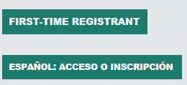
If you have previously registered with VIRTUS online, do not register for a new account. Please contact your local administrator at your location or the Office of Child and Youth Protection at SafeEnvironment@dioceseofjoliet.org.

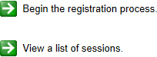
Click on this link to access the VIRTUS Registration page: https://www.virtusonline.org/virtus/reg_2.cfm?theme=0&org=17156 Or:
Go to http://www.virtusonline.org

On the left side of the screen, click on First-Time Registrant to begin registration. To proceed, click on Begin the registration process.

Select the name of your organization Joliet - Diocese (from the pull- down menu, by clicking the downward arrow and highlighting your organization). Once your organization is highlighted, click Select.
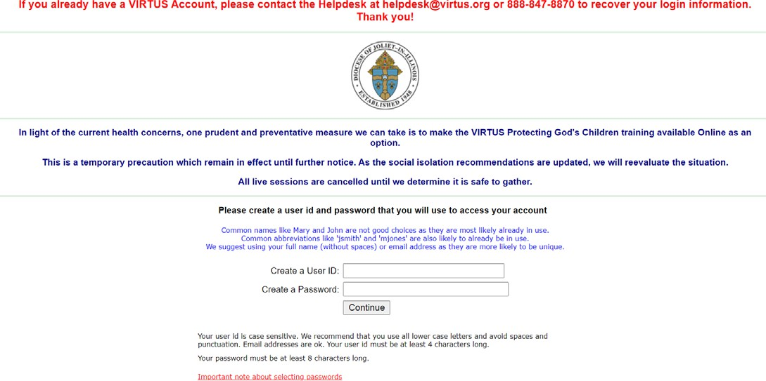
Create a User ID and Password you can easily remember. The password must be at least 8 characters and may not be the word “password.” A password is necessary for all participants. This establishes your account with the VIRTUS program. If your preferred User ID is already taken, please choose another ID. We suggest the use of email addresses as usernames.

Click Continue to proceed.
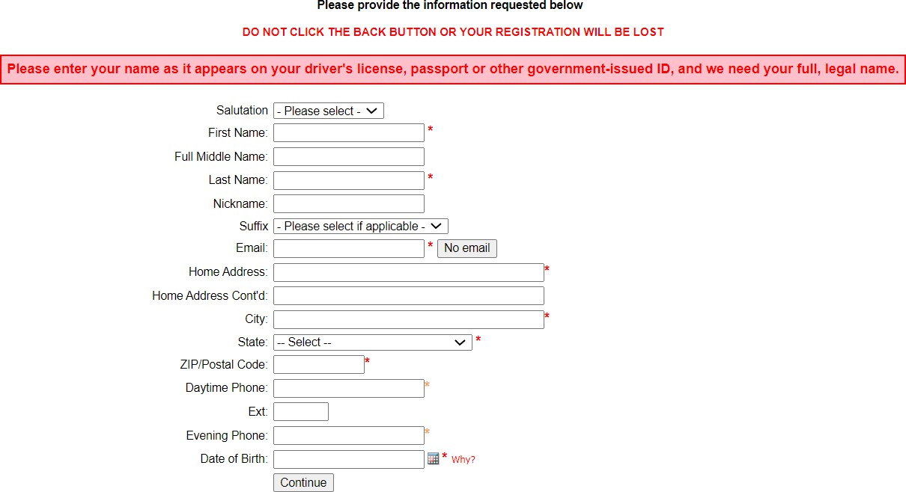
Provide all the information requested on the screen.
Several fields are required, including: First & Last Name, Email Address, Home Address, City, State, Zip, Phone Number, and Date of Birth. When entering your name, please enter your legal name as it appears on your driver’s license, state ID, or passport.
(Note: Do not click the back button or your registration will be lost.)
Click Continue to proceed.

If you do not have an email address, consider obtaining a free email account at mail.yahoo.com, or any other free service.
This is necessary for your Safe Environment Coordinator to communicate with you. If you cannot obtain an email address, enter: noaddress@virtus.org.
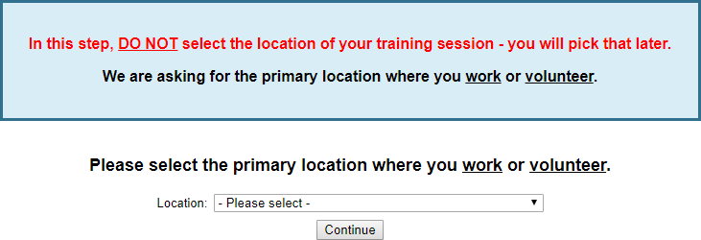
Select the PRIMARY location where you work or volunteer by clicking the downward arrow and highlighting the location.
Click Continue to proceed.
Note: If you serve at multiple diocesan locations, you will be prompted to select those additional locations in future screen(s).

Diocese of Joliet Registration Instructions

Your selected location(s) are displayed on the screen.  Please select the primary role you perform at this location and enter a brief description of your title or position in the “Title or Position of Service” box.  Select Continue to proceed.  If you are an Employee at a Parish or School, please select any additional roles (also known as a Secondary Role).  If you are a Volunteer, please select any additional roles (also known as a Secondary Role).  If you are a Non-employee/Non-volunteer/Contractor, please select the following additional role if applicable (also known as a Secondary Role). | 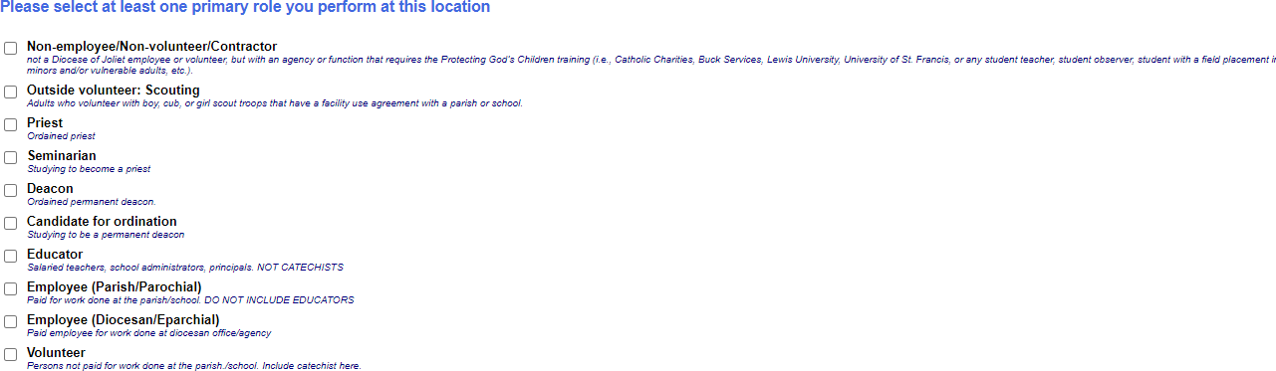  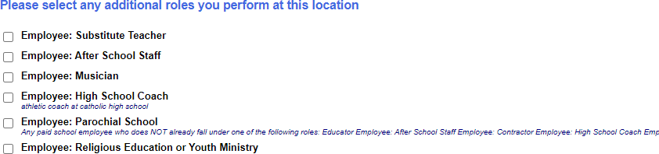  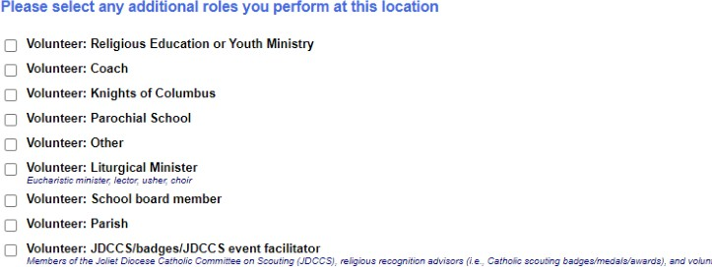  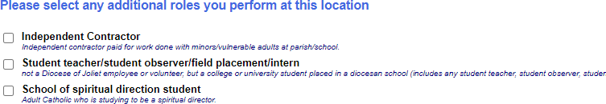
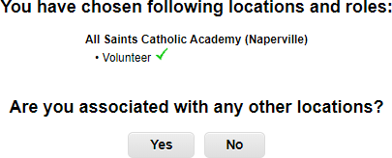
Select Yes if you are associated with any other locations. Select No for no other locations.
.

Diocese of Joliet Registration Instructions

Please answer the four questions. Click Continue to proceed. |  | 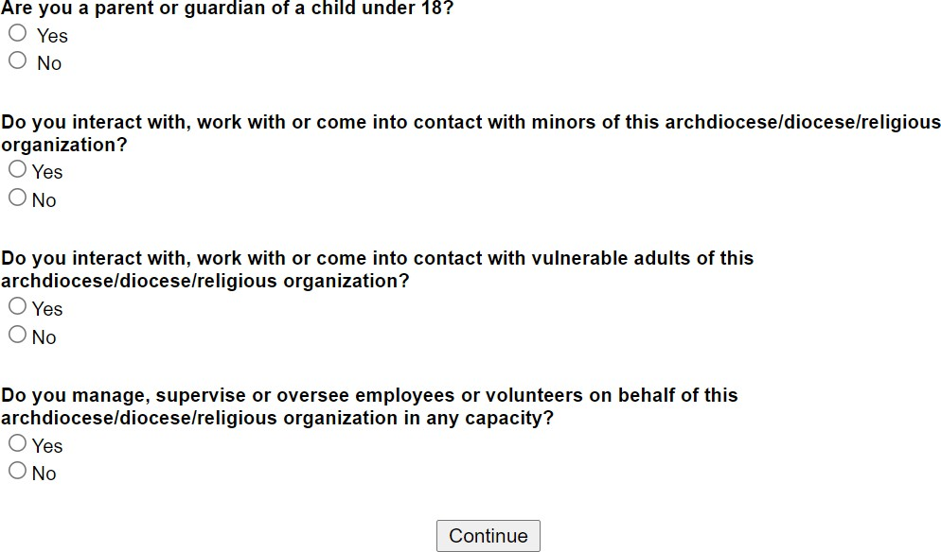
Please review the following and respond:  - Policy Regarding Sexual Abuse of Minors and Vulnerable Adults (rev 7-15-2021)  To proceed, please Confirm by clicking on: “I have downloaded, read, and understand these guidelines” and enter your full name and today’s date.  Click on Continue. |  | 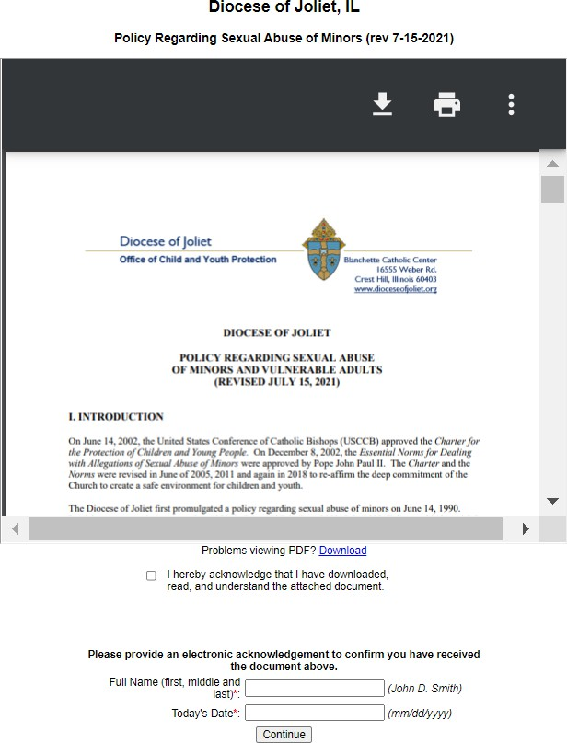
Please review the following and respond:  - Standards of Behavior for those Working with Minors and Vulnerable Adults (rev 7-15-2021)  To proceed, please Confirm by clicking on: “I have downloaded, read, and understand these guidelines” and enter your full name and today’s date.  Click on Continue. |  | 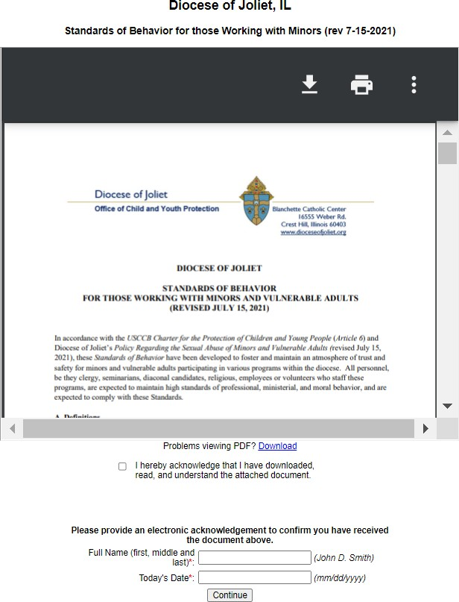

Diocese of Joliet Registration Instructions

If you volunteer in a repetitive role (please see your local administrator), please print the Adult Volunteer Application. Once the form is completed, signed, and dated, please return to the volunteer coordinator of parish/school where you are volunteering. The volunteer coordinator will then provide to the local administrator to enter the date the form was completed into your VIRTUS account.  Click on Continue. | 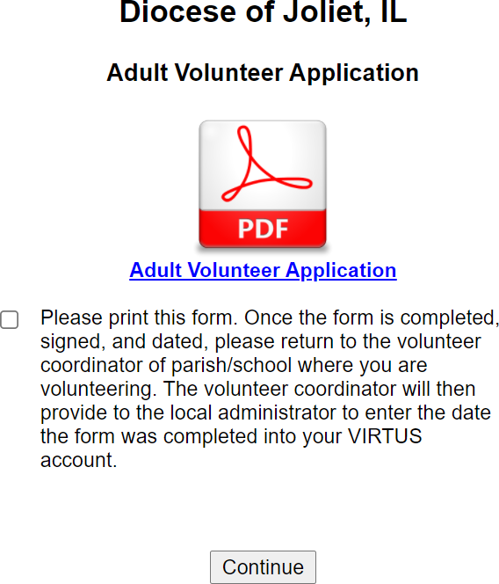
If you have not attended a VIRTUS Protecting God’s Children
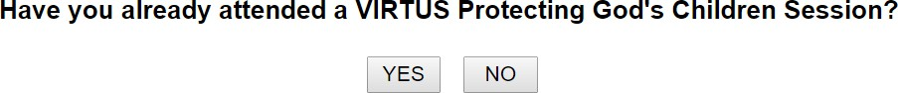
session, choose NO.
Otherwise, choose YES. You will need to know the date and location of the VIRTUS Protecting God’s Children session you
attended in the Diocese of Joliet.
If you chose NO during the previous step, you will be given the option to select VIRTUS Protecting God’s Children for Adults (Online Training) in either English or Spanish. It will take approximately 80 to 95 minutes to complete the training. Please select ‘Go To Training’ and the online Protecting God’s Children for Adults training will be accessible if chosen as the selected training.  Please note: High school minors who register for VIRTUS accounts must select VIRTUS Healthy Relationships for Teens  2.0 (Online Training).  If you chose YES during the previous step, you will be presented with a list of all instructor led VIRTUS sessions conducted in the Diocese of Joliet. Choose the session you attended by clicking the downward arrow and highlighting the session -- then click Complete Registration.  Please note: if you took a Protecting God’s Children class in a diocese other than the Diocese of Joliet, please contact your local administrator or the Office of Child and Youth Protection at SafeEnvironment@dioceseofjoliet.org and provide the date, location, and diocese where you took the training. | 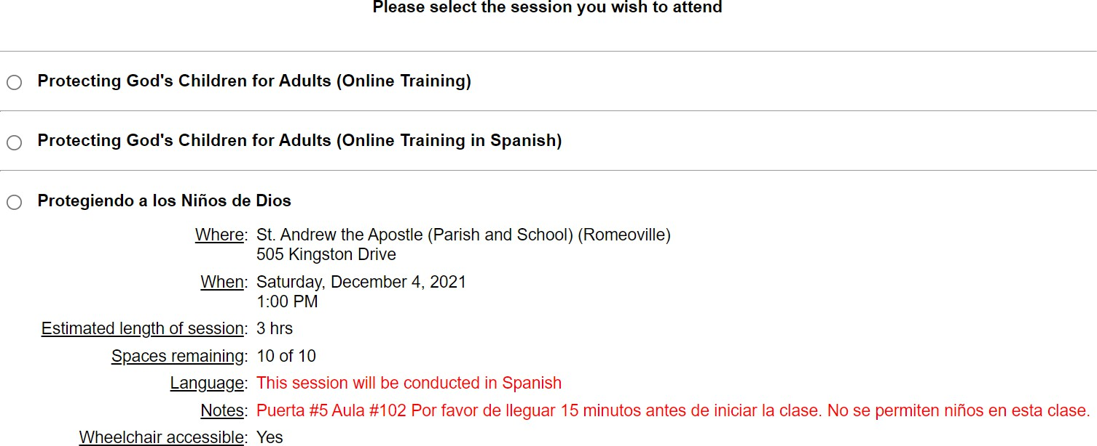
As part of our efforts to create and maintain a safe environment for  children, volunteers, and staff we must conduct a criminal background check.  If you are a NEW EMPLOYEE/APPLICANT, please contact the hiring manager for instructions to be fingerprinted.  If you are a VOLUNTEER or CONTINUING EMPLOYMENT, please follow the instructions to conduct a name-based background check through the Selection.com website. | 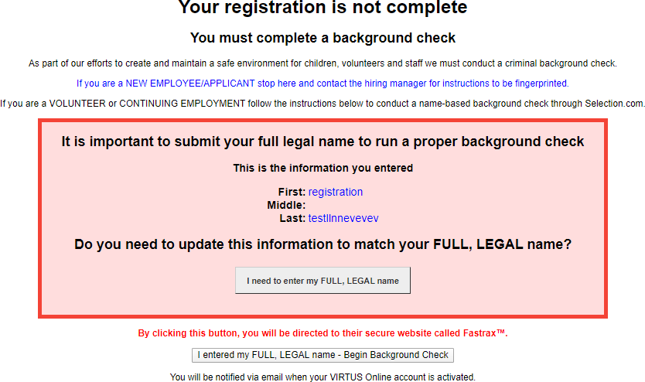

Diocese of Joliet Registration Instructions

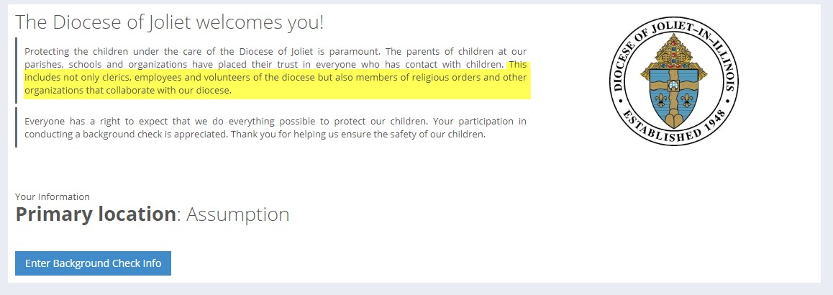
You are now within the secure website of FASTRAX®. Please click on Enter Background Check Info to proceed. You must complete the release form in its entirety once you click on Enter Background Check Info. or an error will be created and you will be asked to complete the release form again.
Please complete the steps within the background check process, which includes reviewing the inquiry release, entering applicant information, a final review, and the submission of the background check release form.
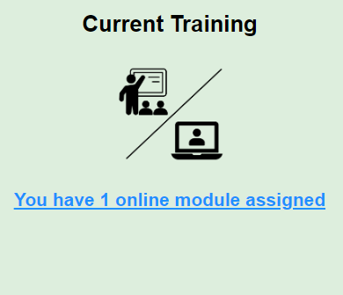
If you selected online training, please click ‘You have 1 online module assigned’ within Current Training, and then the green circle to begin the Online Training.
Upon completion, the last screen will allow you to print a certificate for your records, and you will always have the ability to log back into your account and access the certificate.

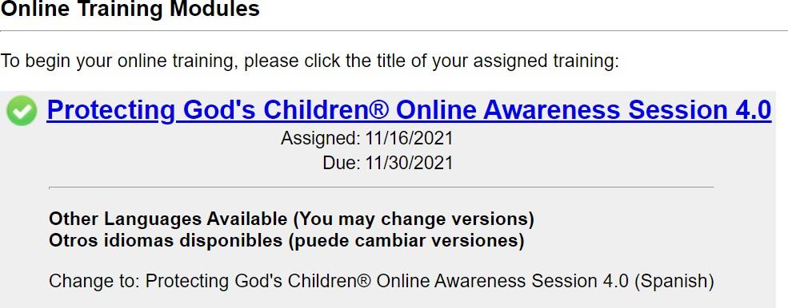
Once you complete any online VIRTUS training, your VIRTUS account will automatically be populated to reflect that the training was completed.

If you have additional questions about VIRTUS Online training, please contact the VIRTUS Help Desk at 1-888-847-8870.

To contact the name-based background check provider, Selection.com, please contact their helpdesk at 800-325-3609.

Thank you for completing the registration process!

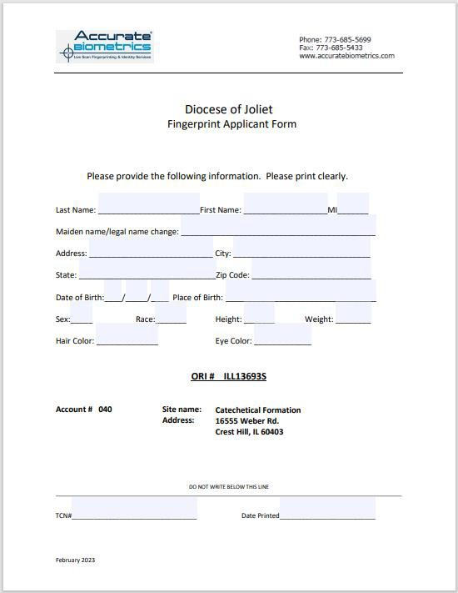
THIS FORM MUST BE PRESENTED IN PERSON AT TIME OF FINGERPRINTING.

—Page Intentionally Left Blank—


Office of Catechetical Formation
Deacon Anthony Clishem, Ed.D
aclishem@dioceseofjoliet.org 815-221-6142

Formation for School of Spiritual Direction Students

School of Spiritual Direction Students – if you have not done so – Set Up Your Free Franciscan at Home Account Now
- Go to https://franciscanathome.com/ .
- Scroll down & click on “Individual Subscriptions.”
- Click on “Free Sign Up” (the parish where you work has an institutional subscription).
- Click “create a new account.”
- Complete all the required fields in the form and click “Create new account” button.
- On the next screen, for diocese, select “Diocese of Joliet” from the drop-down menu.
- Choose the DOJ|Blanchette Center as your institution on the drop-down menu that appears.
- Click the “Sign Up” button.
- The next screen will be your dashboard with full access to content.
- The next time you log in, go to https://franciscanathome.com/ and enter the email address and password you created in Step 5.

—Page Intentionally Left Blank—

